Case 1-EUR-France-Paris Basin-Mid Paleo-Mousterian-Levallois-Homo Nenderthalensis-100-30 kya

flint blond white patina of the Paris Basin Middle Paleolithic. period of the Mousterian type of debitage Levallois method 100.000 TO 30.000 BC
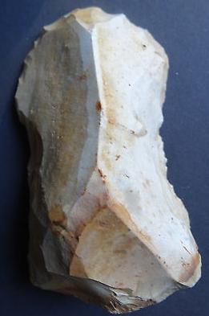

Case no.:
Accession Number:
Formal Label:
Display Description:
LC Classification:
Date or Time Horizon:
Geographical Area:
Map:
GPS coordinates:
Cultural Affiliation:
Media:
Dimensions:
Weight:
Condition:
Provenance:
Discussion:
References:

